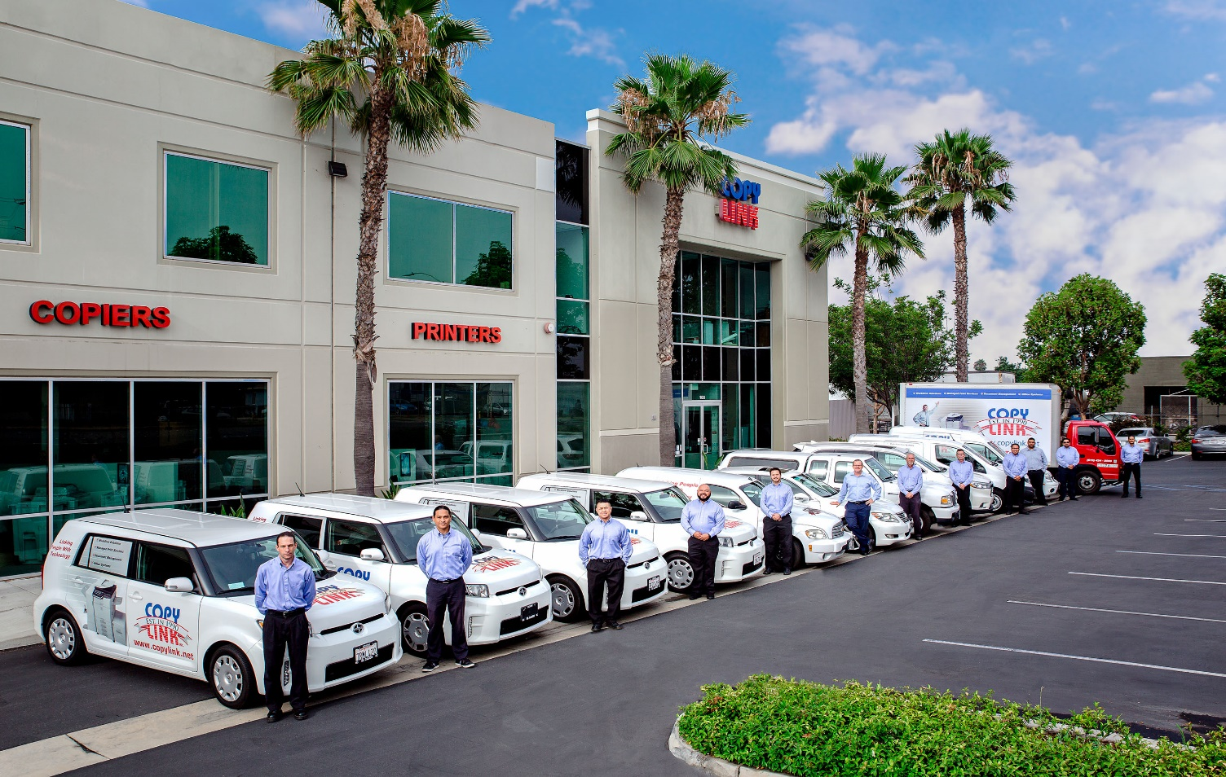

**Trusted Resource for Office Equipment**

**A Proposal For**

**Ocean Charter School**

Dear Maryangee,

Thank you for considering **Copy Link, Inc.** to assist you with your upcoming office equipment decision. From our recent discussion, I am submitting the following proposal for your approval.

When selecting an Office Solutions system there are many variables to consider: The company, the quality and features of the product, the costs, and most importantly the customer service and support you will receive after the sale. **Copy Link** has been in business since 1990 and we are locally owned and operated. Our “***Total Satisfaction Guarantee***” ensures your satisfaction now and into the future. We understand technology is important, but it is our people that make the difference.

Whether you are implementing a document management system, leveraging our network services group, updating your equipment, or simply sourcing office supplies, we have structured our business to provide your organization with excellent customer service.

I appreciate the opportunity to propose a solution for your company. I look forward to earning your trust.

Sincerely,

Nick Beevers

Account Executive

**Copy Link, Inc**.

**Our Mission**

**It is our mission to be the office solutions partner our clients and community can count on.**

**We will be responsible and dependable with a sense of urgency**

**that guarantees results and satisfaction.**

**Copy Link is the Right Choice!**

At Copy Link we have built our business one satisfied customer at a time. When evaluating a company to meet your office equipment needs there are many issues to consider. We invite you to compare the services and benefits you will receive at Copy Link against any of our competitors. We are confident that Copy Link will rise above the rest!

|  |  |  |  |
| --- | --- | --- | --- |
| **Features and Benefits** | **Copy Link** | Company B | Company C |
| Locally owned and operated | **√** |  |  |
| Serving San Diego County since 1990 | **√** |  |  |
| Live person ready to take your call | **√** |  |  |
| Local in-house Help Desk for immediate resolutions | **√** |  |  |
| Staff that know you and recognize your account | **√** |  |  |
| 4 Hour service response time | **√** |  |  |
| Service technician’s average tenure of 16 years | **√** |  |  |
| All vehicles stocked with over $7500 in parts, all the time | **√** |  |  |
| Guaranteed uptime performance | **√** |  |  |
| Guaranteed loaner system if yours is out of service | **√** |  |  |
| Master Technicians on Staff | **√** |  |  |
| Premier Dealer and Authorized Service center | **√** |  |  |
| Award Winning Product Lineup | **√** |  |  |
| A company culture that exemplifies a sense of urgency | **√** |  |  |
| An accessible experienced Management Team | **√** |  |  |

**Copy Link is a leader in connecting digital, multi-function devices to a wide variety of networks and operating platforms.**

**We have experts in all types of software applications, specializing in:**

• Data Security Experts to help keep your data secure and compliant and with HIPAA, SOX and other standards that affects today’s businesses.

• Connectivity Specialists to connect you to email, network and cloud based services such as OneDrive, SharePoint, Exchange, Dropbox, Gmail, Google Drive and more.

• Active Directory and Office 365 integration

• Managed Print Service Specialists to help control printing costs associated with managing a fleet of printers, MFP’s and fax devices.

• Production Printing Experts to help enhance workflows for high volume environments

• Scanning and document indexing, routing and management software

• Secure print, copy tracking and accounting software

• Document imaging, archiving and retrieval software

• Ongoing research and recommendations of the best third-party software solutions

**OEM Partner Support**

Copy Link operates with full sales and technical support from our

Original Equipment Manufacturer partners:











**Your Support Team**

**Nick Beevers**

Account Executive

Phone: 619.424.8000

Email: [@copylink.net](mailto:Salesrep@copylink.net)



**Kevin Marshall**

President and Owner, over 33 years in the industry

Phone: 619-4242-8000

Email: [Kevin@copylink.net](mailto:Kevin@copylink.net)



**Nick Beevers**

Sales Manager, over 30 years of industry experience

Phone: 619-424-8000

Email: [nbeevers@copylink.net](mailto:nbeevers@copylink.net)



**Bernie Hensgens**

Director of Service, over 30 years of industry experience

Phone: 619-424-8000

Email: [bhensgens@copylink.net](mailto:bhensgens@copylink.net)



**Stacey Key**

Head of Operations, over 30 years of industry experience

Phone: 619-424-8000

Email: [skey@copylink.net](mailto:skey@copylink.net)



**David Polansky**

Director of Technology & Solutions, over 30 years of industry experience

Phone: 619-424-8000

Email: [dpolansky@copylink.net](mailto:dpolansky@copylink.net)

**We value hearing from our customers and encourage you to contact us!**

## Proposed Solution for: Ocean Charter School

Copy Machines Inc.

|  |  |  |
| --- | --- | --- |
| **Qty** | **Equipment** | **Description** |
| **1** | **BP-70C55** | **Sharp 55 PPM B&W / 55 PPM Full-Color Workgroup** |
| 1 | BP-FN14 | 1K Stacking 50-sheet Staple/Saddle Stitch Finisher |
| 1 | **BP-70M90** | **Sharp 90ppm B&W Production MFP**  1K Stacking 50-sheet Staple/Saddle Stitch Finisher |
|  |  | Fax Kit  Extra Paper Tray |
|  |  |  |
| 1 | **BP-70C31** | **Sharp 31ppm Digital Color MFP** |
| 1 | SURGE-PROTECTOR I | SURGE PROTECTOR I (15A/120V) |
| 1 | BP-NT70YA | Inner Finisher |

### Please see attached brochure or specification sheet for more details

|  |  |  |  |  |  |
| --- | --- | --- | --- | --- | --- |
|  | **Lease Months** | **Lease Payment** |  | **Mono CPP** | **Color CPP** |
|  | 63 | $2,755 |  | 45,000 | 4,000 |

### All-Inclusive Maintenance & Supplies:

Relax knowing your system is backed with everything you need to keep your system running productively. Our all inclusive maintenance agreement includes parts, labor and supplies i.e., toner, developer and drum, preventative maintenance and on site service. *(Excludes paper, staples and toner waste collection containers). All applicable taxes will apply.*

* 45,000 Mono copies per month. All additional Mono copies billed monthly at $0.009 per copy.
* 4,000 Color copies per month. All additional Color copies billed monthly at $0.08 per copy.
* 4 hour response time in the metro area and next-day service for out-of-town customers.